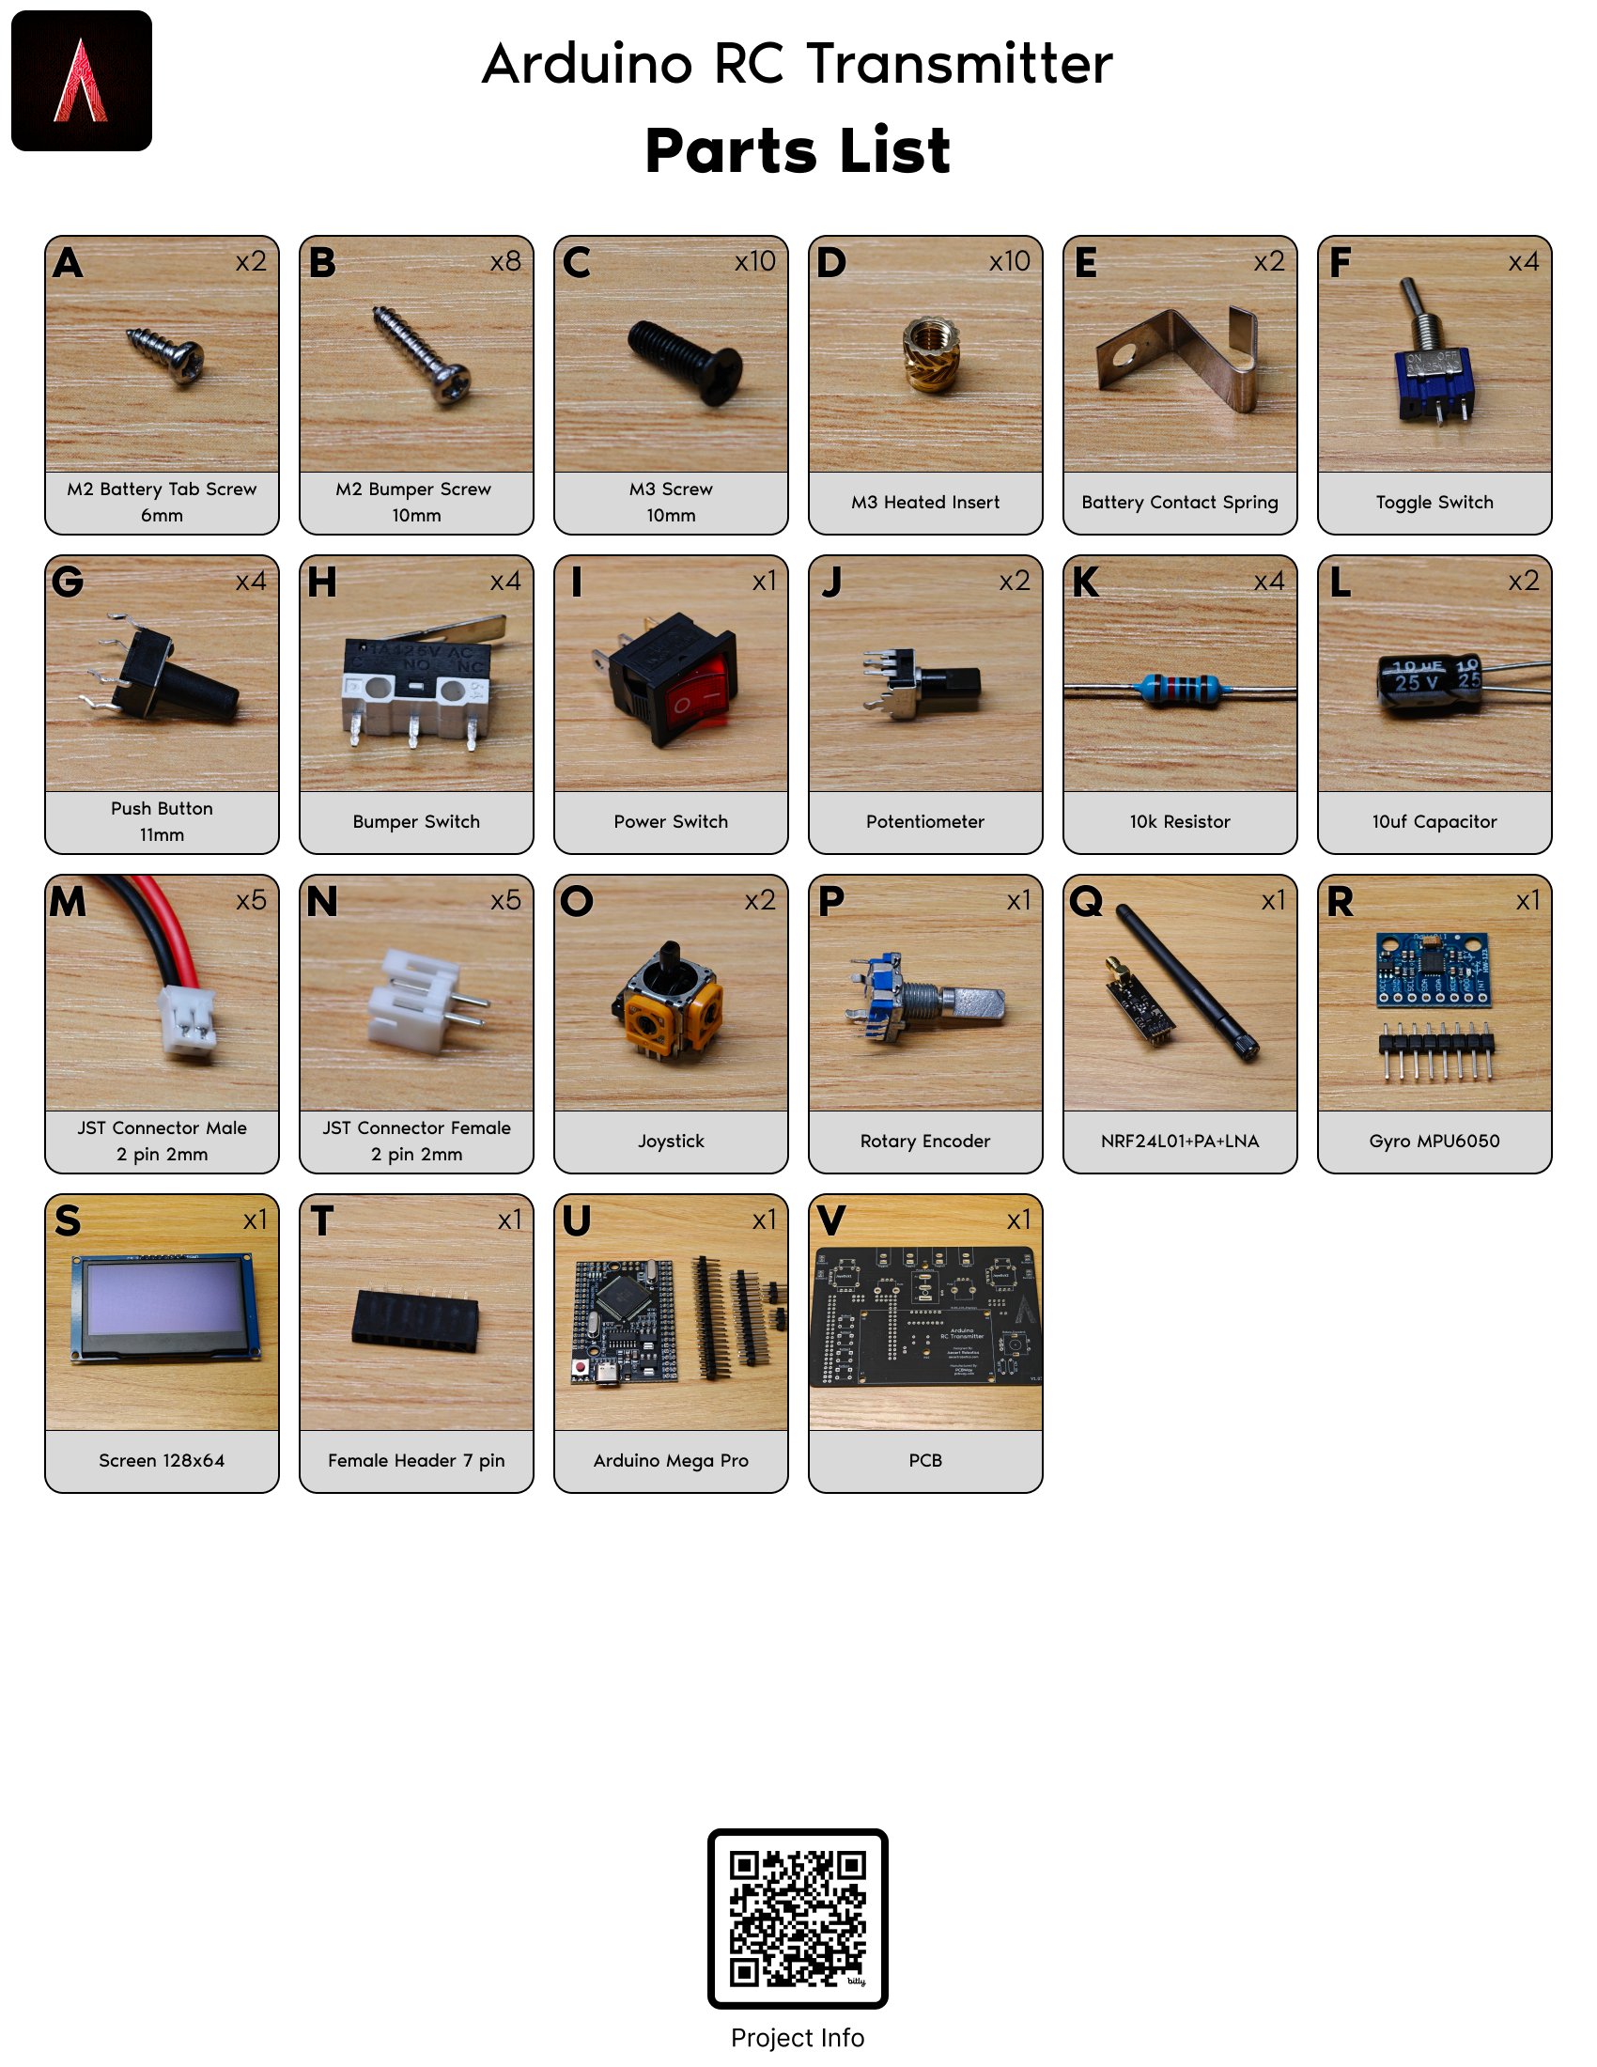

0 - Preliminary

What to do before starting the assembly

1. Using the parts list, make sure you have all the components.
2. The parts list Part letters will be referenced throughout these instructions.
3. You will need to supply the following:
   * Soldering iron
   * hot glue gun
   * Philips head screwdriver
   * 9-volt battery
4. Mentally prepare for this to take about 2-3 hours.

1 - Printing the STL’s

STL’s can be found on the project info page, which is linked at the QR code under the parts list.

1. The case bottom needs supports, nothing else needs supports.
2. I would recommend printing the “Case Parts” group in one color, and the “Cap Parts” group in a different color.
3. I would also recommend printing the button springs on their own build plate with nothing else on it. They are the hardest part to print.
4. While the STL’s are printing, move on to Soldering!

2 - Soldering

Note: although where the parts go into the PCB is mostly self-explanatory, the order you solder them on does matter.

1. Solder 4x **G** (Push Button) on top of **V** (PCB)
2. Solder **U** (Arduino Mega Pro) pins onto **U.** The tall end of these pins goes into the bottom of U and out the top. Place the pins into **V** (PCB) while you solder so there are no alignment issues. Please refer to the tutorial video if you are unsure of how to do this step.
3. Solder **U** (Arduino Mega Pro) on bottom of **V** (PCB)
4. Solder 2x **J** (Potentiometer) on top of **V** (PCB)
5. Solder **T** (Female Header) on top of **V** (PCB)
6. Solder **I** (Power Switch) on top of **V** (PCB) ***Make sure it is in the correct orientation!***
7. Solder **R** (Gyro) pins on **R**. The short pins go into the bottom of **R** and out the top.
8. Solder **R** (Gyro) on bottom of **V** (PCB)
9. Solder 2x **O** (Joystick) on top of **V** (PCB)
10. Solder **Q** (NRF24L01) on bottom of **V** (PCB)

The order of everything else does not matter.

1. Solder 4x **F** (Toggles) on top of **V** (PCB)
2. Solder 2x **N** (JST Connector Female) on top of **V** (PCB) on “Bumper 1” & “Bumper 3”
3. Solder 2x **N** (JST Connector Female) on bottom of **V** (PCB) on “Bumper 2” & “Bumper 4”
4. Solder **N** (JST Connector Female) on bottom of **V** (PCB) on “Battery1” ***Make sure it is in the correct orientation!***
5. Solder **P** (Rotary Encoder) on top of **V** (PCB)
6. Solder 2x **L** (10uf Capacitor) on bottom of **V** (PCB). ***Make sure they are in the correct orientation!***
7. Solder 2x **K** (10k Resistor) on bottom of **V** (PCB)
8. Solder 2x **K** (10k Resistor) on top of **V** (PCB)
9. Solder 4x **M** (JST Connector Male) on the **H** (Bumper Switch) pins “C” and “NO”.
   1. The wires should be cut to a length of about 2 inches before soldering.
   2. These are the 2 pins on the left in the Parts list picture of **H**
   3. Which wire gets soldered to which **H** pin does not matter if you are soldering to the correct 2 **H** pins.

3 - Assembly

How to put it together! You’ll need a screw driver, hot glue gun, and a 9 volt battery.

1. Insert 10x **D** (M3 Heated Inserts) There are 6 in the case bottom, and 4 in the case top.
2. Attach 2x **E** (Battery Contact Spring) using 2x **A** (M2 Battery Tab Screw 6mm). Leave a small gap, do not tighten down yet.
3. Find the **M** (JST Connector Male) that you did not connect to a bumper. Insert it’s wires under the 2x **E** (Battery Contact Spring). The right is positive, and the left is negative. Tighten the 2x **E. *Do not overtighten.***
4. Attach the 4x Bumper Caps to the 4x **H** (Bumper Switch). Use a dab of hot glue before attaching so they stay on.
5. Find the 2x **H** (Bumper Switch) with the **M** (JST Connector Male) soldered to them that were ***not*** cut short. Attach them to the case bottom using 4x **B** (M2 Bumper Screw 10mm)
   * The side that gets pressed in should face inward.
   * Make sure they can be pressed without getting stuck.
   * ***Do not overtighten.***
6. Plug in the 3x **M** (JST Connector Male) wires into the associated 3x **N** (JST Connector Female) that are on the PCB.
7. Attach **V** (PCB) to the case bottom using 2x **C** (M3 Screw 10mm). Make sure the 3x **M** (JST Connector Male) wires don’t get pinched.
8. Insert the 2x screen spacer 3d prints onto **V** (PCB) and plug in **S** (Screen)
9. Repeat Step 5 on the case top with the remaining 2x **H** (Bumper Switch).
10. Plug in the 2x **M** (JST Connector Male) wires into **V** (PCB) and attach the top case to the bottom case. Make sure the wires don’t get pinched
11. Attach the 3d printed caps.
    * 2x **J** (Potentiometer) caps
    * 2x **O** (Joystick) caps. These may need hot glue.
    * 1x **P** (Rotary Encoder) cap.
12. Attach 4x button springs to the top case. You may need to use a tool to properly compress the connectors into the top case. They should at least be flush.
13. Attach the 4x button caps to the button springs. A to D, top to bottom.
14. Screw in the 2 side handles using 8x **C** (M3 Screw 10mm). ***Do not overtighten.***
15. Screw on **Q** (NRF24L0) Antenna
16. Insert 9 Volt battery (Not included). ‘+’ on the right, ‘-‘ on the left.
17. Attach 3d printed battery door.
18. Power on!